**Transformations**

Transformation = changes the vertex/vector coordinates

* Types:
  + 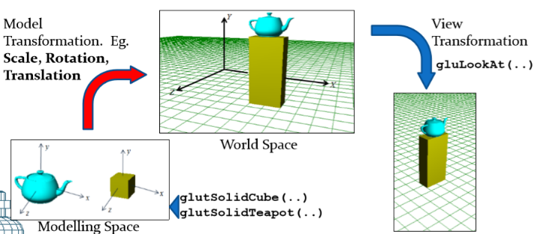Transformations of objects within the same frame: Egs. Translations, rotations and scale transformations. These transformations are called Model Transformations.
  + Projection transformations. These are based on the camera’s frustum parameters.

Objects create their own local coordinate space then transformed into world space.

OpenGL supports the following types of three-dimensional model transformations:

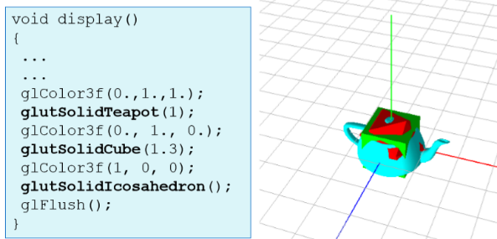Translations: glTranslatef(a, b, c);

Rotations: glRotatef(angle, l, m, n);

Scale Transformations: glScalef(sx, sy, sz);

Generalized transformation: glMultMatrixf(mat);

**Model Creation**

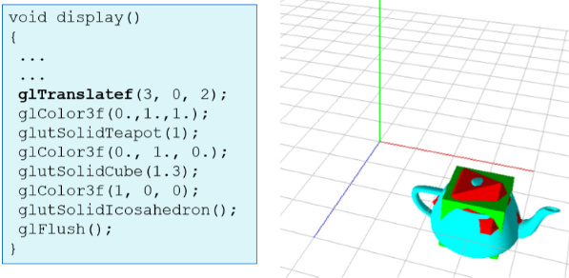If a model doesn’t have its transformation specified. Then default = origin (0) (Fig 1)

Fig 2 includes **glTranslatef(3, 0, 2);** therefore changes the translation.

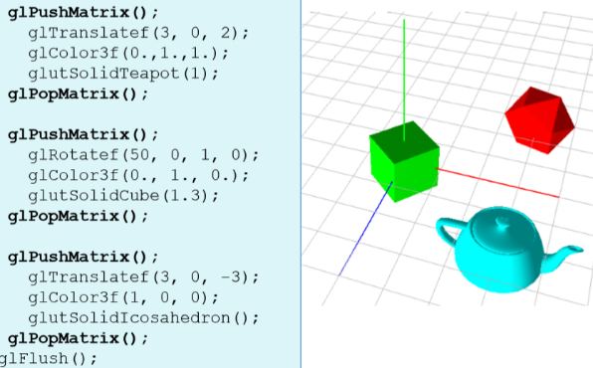Fig 3 shows how we can change the transformations of each object.

glPushMatrix();

… code for object …

glPopMatrix();

**Translation**